**Docker Task-1**

1. **Setup a virtual machine using Ubuntu image.**
2. **Install docker on ec2.**
3. **Pull 5 docker images. (nginx, Apache tomcat, ubuntu, Jenkins, SonarQube)**
4. **Run nginx container and expose on port 81.**
5. **Delete the Apache tomcat image from local.**
6. **Inspect the Jenkins image, SonarQube image.**
7. **Run Jenkins container and run one sample job**

**1.Setup a virtual machine using Ubuntu image.**

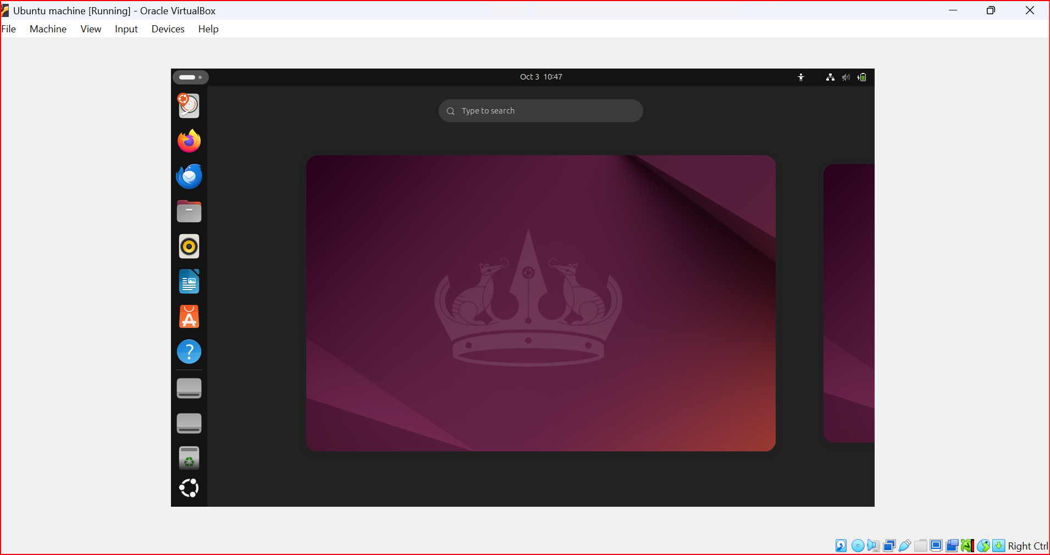

**2. Install docker on ec2.**

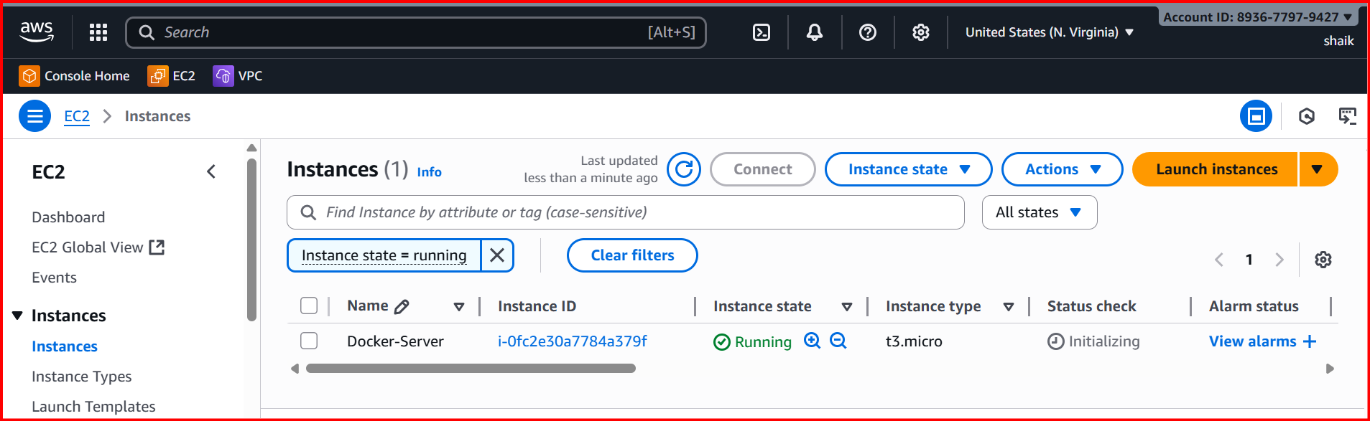

**Yum -y install docker**

**Systemctl start docker**

**Systemctl status docker**

**Docker –version**

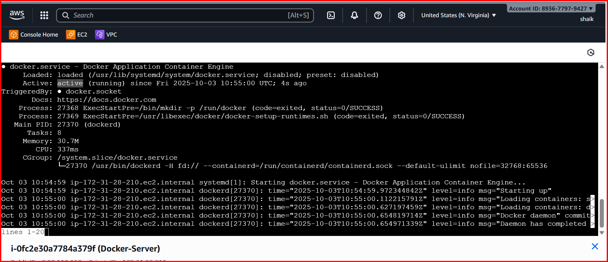

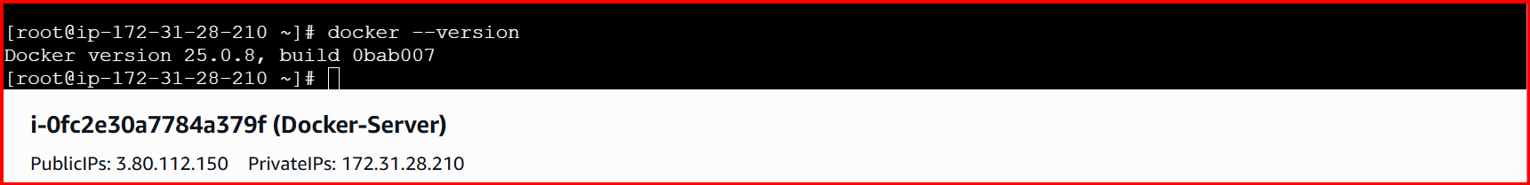

**3. Pull 5 docker images. (nginx, Apache tomcat, ubuntu, Jenkins, SonarQube**

**Ubuntu 🡪 docker pull ubuntu**

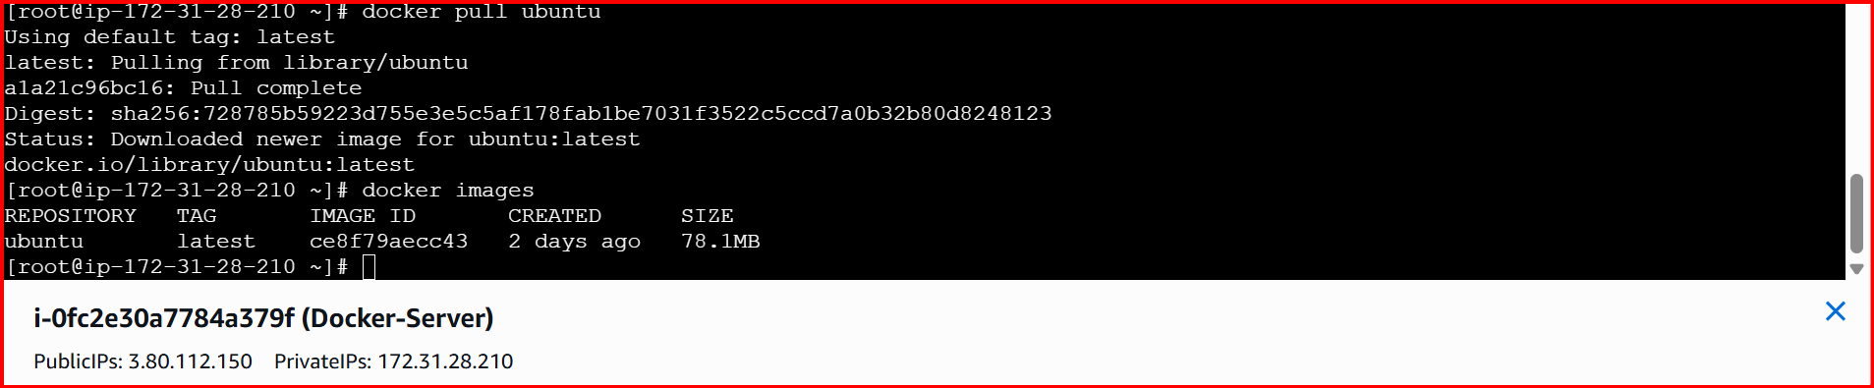

**Nginx 🡪 docker pull nginx**

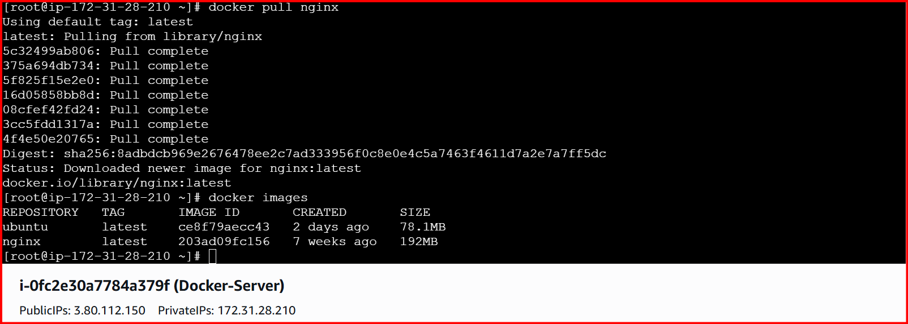

**Tomcat 🡪 docker pull tomcat**

**Jenkins 🡪 docker pull Jenkins:2.60.3**

**Sonarqube 🡪 docker pull sonarqube**

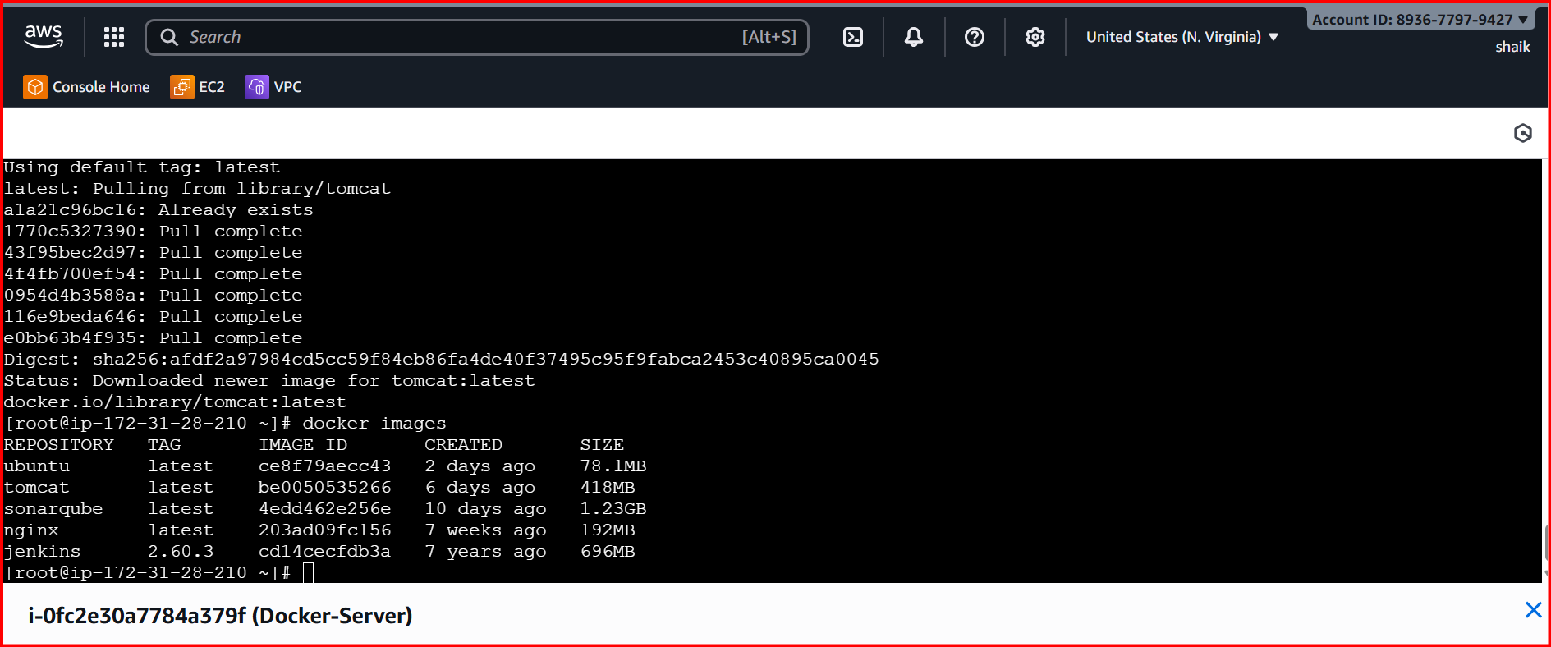

**docker run -d --name nginx -p 80:80 nginx**

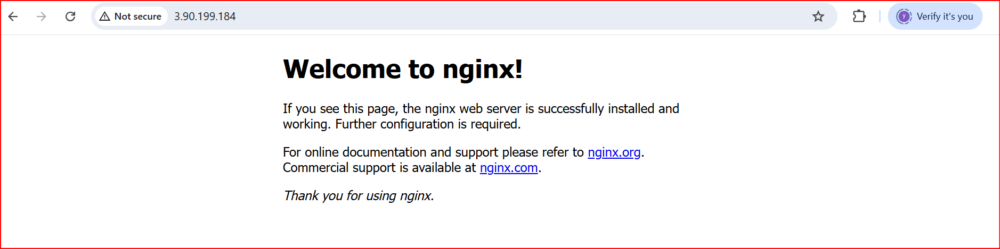

**docker run -d --name tomcat -p 8080:8080 tomcat**

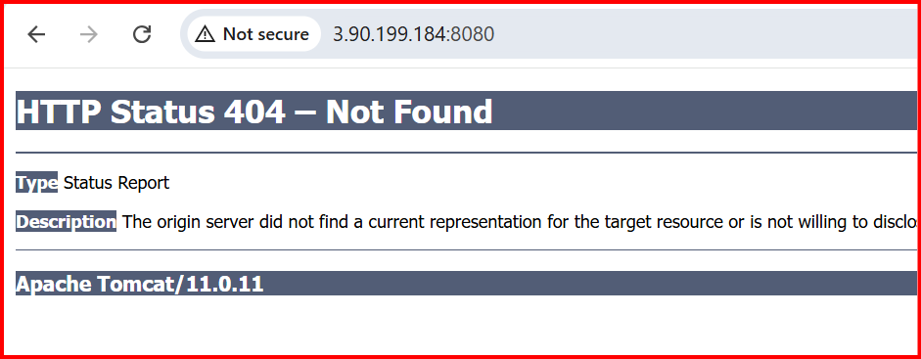

**docker run -d --name sonarqube -p 9000:9000 sonarqube**

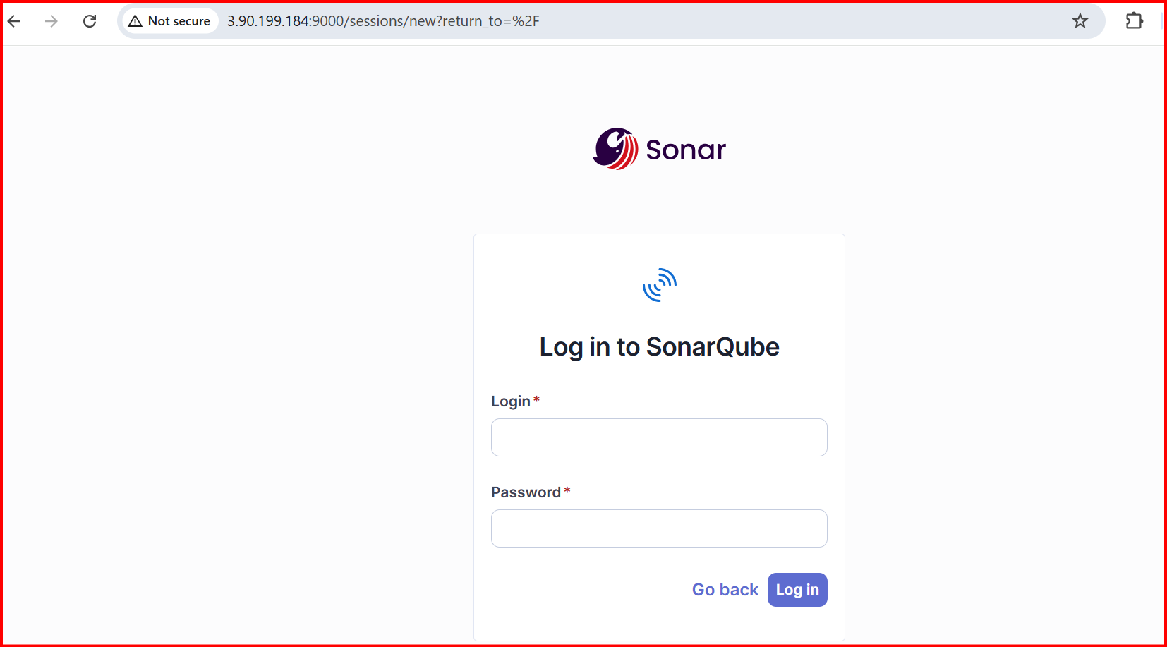

**docker run -d --name jenkins -p 8081:8080 -p 50000:50000 jenkins/jenkins:lts**

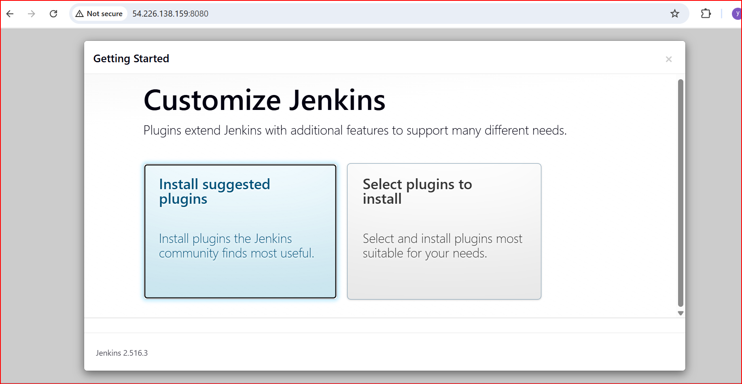

**4. Run nginx container and expose on port 81.**

**docker pull nginx**

**docker run -d -p 81:80 --name mynginx nginx:latest**

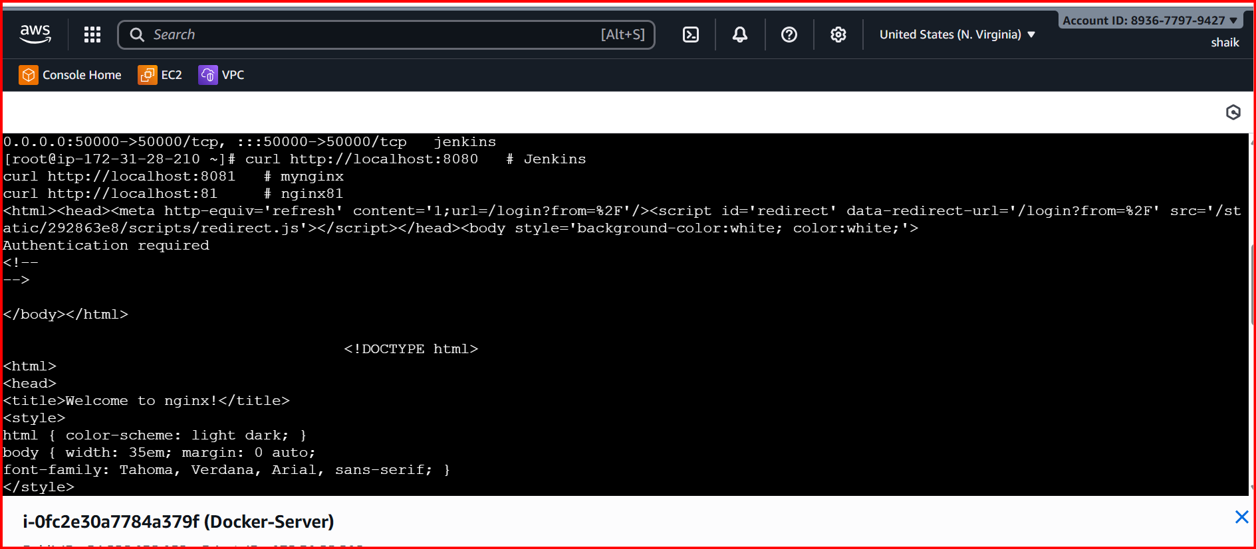

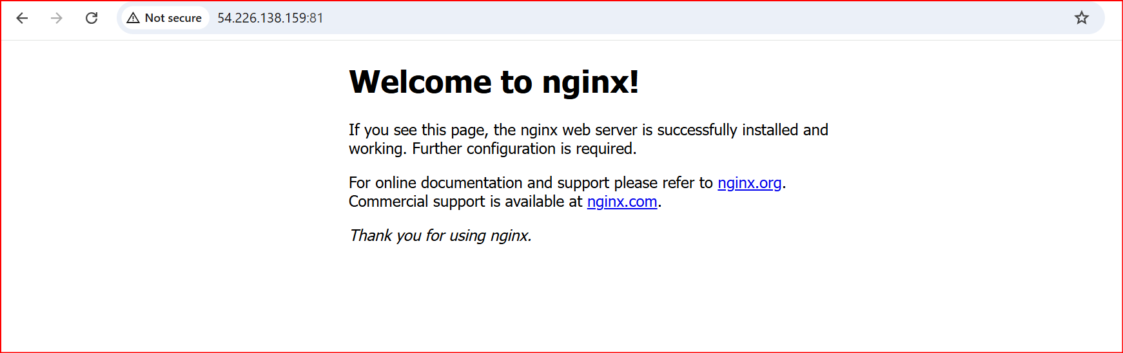

**5. Delete the Apache tomcat image from local.**

First, we have stopped the server with container

**docker ps -a**

**docker stop <tomcat_container_id>**

**docker rmi be0050535266**

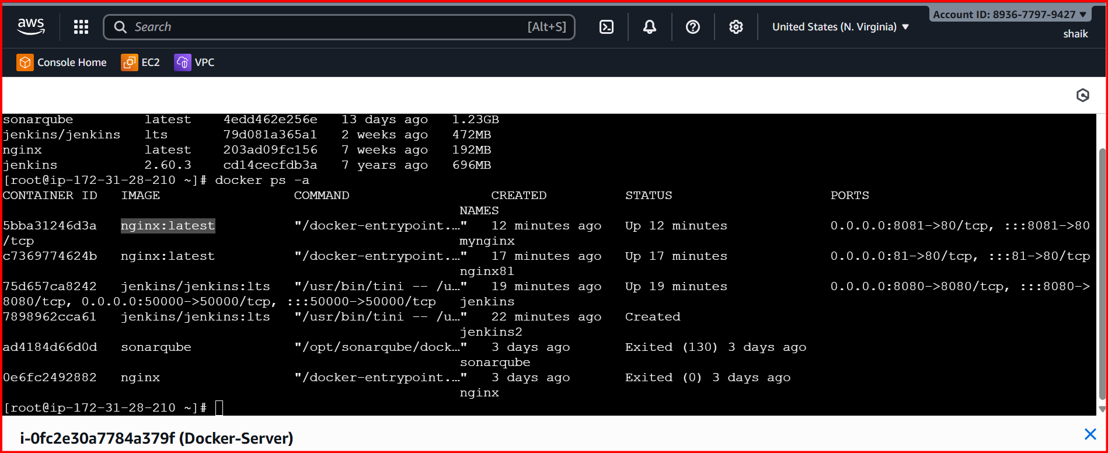

**6.Inspect the Jenkins image, SonarQube image.**

**Inspect Jenkins image**

**docker image inspect jenkins/jenkins:lts**

* **This will output JSON with all details, including:**
  + **Image ID, creation date, size**
  + **Environment variables (Env)**
  + **Default command/entrypoint (Cmd / Entrypoint)**
  + **Exposed ports (ExposedPorts)**
  + **Volumes, labels, architecture**

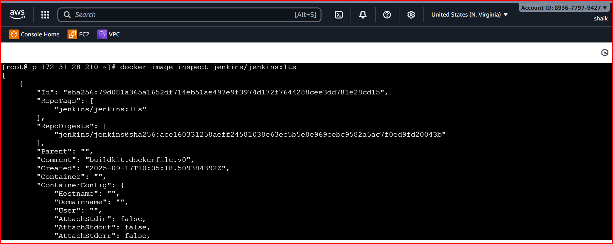

**Inspect SonarQube image**

**docker image inspect sonarqube:latest**

* **Similar output as Jenkins. You can check:**
  + **Default ports (9000/tcp)**
  + **Environment variables like SONARQUBE_JDBC_\***
  + **Entrypoint (/opt/sonarqube/bin/...)**

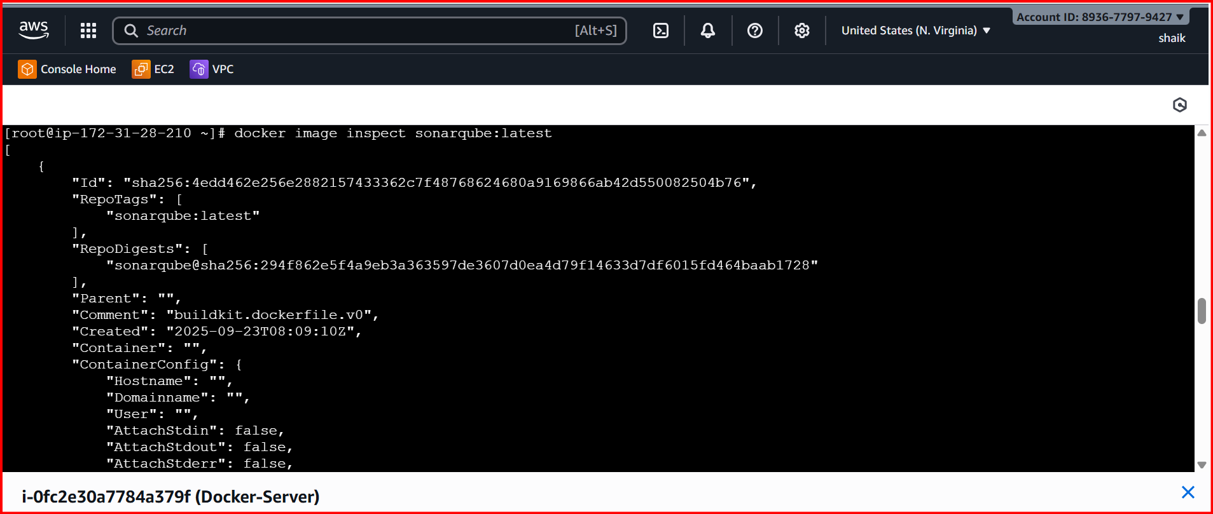

**7.Run Jenkins container and run one sample job.**

